Making Mavericks Mainstream:
to raise up collaboration and knowledge-sharing
to the highest level of workforce productivity and business impact

Laci Loew
EVP Marketing, Pandexio

Robert Danna
Executive Chairman, Pandexio

Charles Jennings
Co-founder, 70:20:10 Institute

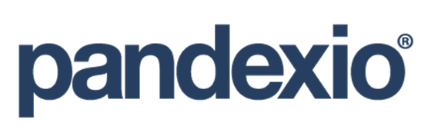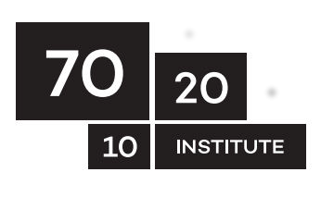

Introduction

Today’s economies are driven by continual innovation, the rapid evolution of fresh business models and new technologies to lift the cap from today’s productivity plateau. Forward-leaning and non-conforming leaders who seek real, measurable business results know they cannot be achieved one course, one document, one experience at a time and have long since stopped believing that e-learning, microlearning or just more great content is an answer to either performance issues or the current fall in productivity. Today, they are mavericks and the sooner they become mainstream, the greater the odds of real business results being achieved and sustained in more than pioneering organizations. These unorthodox leaders are outliers, and they signal where the world of HR and business performance is going.

Rampant workforce collaboration does occur today – in all organizations. However, the sharing is mostly tactical and transactional in nature: Who should I speak to about XYZ? Did you find that new course helpful? Are you running behind on that project? What are the guidelines for the initiative? When does the new cycle commence? This type of collaboration is overwhelmingly driven by the desire for routine answers rather than high-value, intangible intellectual capital –actionable insights -- that informs critical business decisions, reduces business risk, improves organizational agility, enhances the employee experience, and drives up performance and productivity.

Sharing of actionable insights is becoming increasingly critical to solve all the other potential drains on worker productivity: too many collaboration tools, much too much information and content, multiple enterprise software platforms, and constant change initiatives to name a few. The typical form of enterprise collaboration today is, at best, offering tactical benefits, and at worst, actually impeding worker productivity.

Workforce Productivity Is Spiraling Down

Productivity is defined in economic terms as delivering work in a timely manner and refers to the quality, state, or fact of being able to generate, create, enhance, or bring forth goods and services. Few would argue that productivity is something that employers often seek to support and encourage.

A recent report from the U.S. Bureau of Labor Statistics shows worker productivity is falling (https://www.bls.gov/opub/btn/volume-6/below-trend-the-us-productivity-slowdown-since-the-great-recession.htm).

Figure 1. Workforce Productivity (Percent Change) Falling

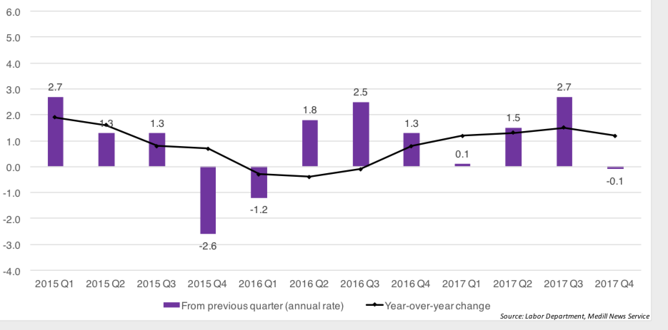

Many leaders are confused about how to solve for it, and it is top of mind for the C-suite and senior leaders.

Global O.C. Tanner research shows that leaders around the world seek employees who are experts doing really great work because they are sharing their insights so others can do the same. The O.C. Tanner Study (https://www.octanner.com/insights/white-papers.html) looked at over 1.7 million cases of great work worldwide and found that the skills that deliver such work and wisdom leverage critical thinking shared across the enterprise. In fact, 88 percent of great work and insight sharing starts with an employee asking an inquisitive question: “Why don’t we …?” or “Should we try ...? or “How can we improve on …?” Furthermore, 72 percent of insight sharing happens because the employee speaks to many people about their ideas, and incorporates diverse knowledge and other experts’ viewpoints into the solution design.

The true goal of 21st century insight-driven companies is making a difference for customers, delivering new and innovative solutions, creating a culture that strengthens teams. Doing so requires productive workforces sharing insights. Yet, productivity is dropping off. So, what to do?

New Approaches Are Needed to Boost Productivity

To get started on lifting the cap from today’s productivity plateau, companies are (a) building new cultures that empower employees to create innovate and share insights and (b) seeking new technology solutions that facilitate the spread of actionable insights.

“Companies today are “living organizations” that must constantly adapt to market and industry pressures in order to stay competitive. This mode of continual change means they can no longer operate effectively in formal, rigid frameworks. Most executives recognize this shift—92 percent of surveyed leaders believe that redesigning their organization is either very important or important, and many are moving away from formal, functional structures and redesigning their organizations to be dynamic and team-based (Deloitte).” Moving to a networked structure helps workforces generate expertise and share insights across the enterprise thus enabling organizations to become more flexible and innovative.

The ‘sharing enterprise’ is a natural product of our hyper-linked society. With this comes an urgent need to deploy new technologies to make capturing and sharing expertise and insights both straightforward and part of everyday work patterns.

To better understand the technology component of boosting productivity, let’s start by taking a quick look at the market. The global learning management system (LMS) market is estimated at over $5billion (Bersin). The global enterprise performance market (EPM) is estimated at $7billion and projected to be almost $12billion by 2023 (Markets and Markets). Yet, LMSs and learning experience platforms (LEPs/LXPs) and EPMs are not intended, nor designed, to enable insight sharing. Couple that with the fact that over two thirds of organizations cite “increasing workforce productivity” as a major factor in evaluating next generation technologies (Ventana Research), and we see the need to revisit today’s technology strategy.

As such, successful organizations recognize that traditional technology (LMS, LEP/LXP, EPM, etc.) alone, is simply not fit for purpose. Accordingly, they are adding new workforce productivity technology to their HCM and IT technology stack.

Figure 2. New Workforce Productivity Technology Lifts the Cap on Today’s Productivity Plateau

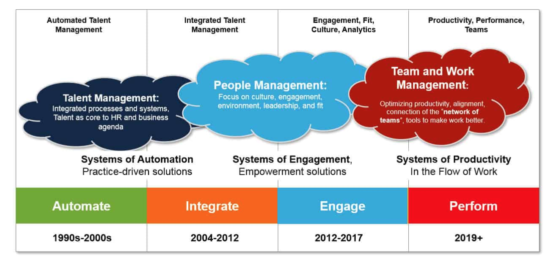
Source: 2019 HR Technology State of the Market Report, Josh Bersin

Workforce productivity technology is intentionally designed and promises to exploit the workforce’s insights and facilitates sharing of continuous flows of expertise. This is high-value collaboration that will serve to increase value to customers and clients and achieve real business results.

The Role of Insight Sharing in Building Enterprise Expertise
Insight sharing’s promise and impact, we suggest, lies in its potential to stimulate higher-order thinking in workforces. Through crowd sourcing wisdom and scaling the availability of that collective, tacit knowledge among all, we believe the research referenced herein and other, show a clear relationship between insight sharing and workforce productivity.
As such, insight sharing is quickly garnering attention and unfolding in early adopter organizations. Still, we know that the genesis of insights and their spread across organizational networks vary. The basis of this variation is likely due to normal resistance to change, lack of understanding about what actionable insights are, and misunderstanding regarding how simple the integration is between current technology stacks and workforce productivity technology.

Prohibiting (Costly) Ignorance

“Failures of ignorance we can forgive. If the knowledge of the best thing to do in a given situation does not exist, we are happy to have people simply make their best effort. But if the knowledge exists and is not applied correctly, it is difficult not to be infuriated.”
Atul Gawande
MD and MPH
Harvard Medical School

Many of us have stories of discovering, too late, that others have made the same errors before us but that we were unaware of them. This happens in organizations over and over again. One project team addresses an error and moves on neglecting to document or share the learning from solving the problem. Another project, unaware of what’s gone before, commits the same foul. Lack of reflection and insight, and documentation and sharing, means that the organization learns nothing and that mistakes are repeated. In practice, this leads to added cost, poor business outcomes, disenchanted employees, and other elements of failure.

Simple practices such as documenting and sharing insights address this ‘leaking’ of organizational knowledge.

Every Voice is Heard and Every Employee Matters

Professor Rob Cross has been studying knowledge flows across organizational networks and their impact on individual, team and organizational performance for many years. A recent study by Cross and colleagues found that not only are there performance and productivity benefits for the recipient of shared knowledge, but also for the provider of knowledge insights. Moreover, workforce productivity technology democratizes talent. It does not care if the expert sharing is your CEO or your newest hire. It does not discriminate based on your employees’ geographical location, the color of their skin, their age or orientation. What it does care about is all experts are given the opportunity to have a voice and share their expertise and insights for accelerated productivity and better business results.

In other words, with a networked culture, there is a positive impact on performance by providing insight sharing assistance to your employees. So, who does provide such assistance?

A Provider of a Workforce Productivity Technology

If you agree that workforce productivity is an indicator of business success, then you might wish to know more about workforce productivity technology. Workforce productivity platforms are the newest technology that today’s most successful organizations are using to ensure that their employees are working at optimal levels.

So why is this new technology a significant contributor to lifting the cap from today’s productivity plateau? The answer, at least in large part, lies in the intended design of the technology –for the first time ever – to enable every employee to move information to insights to impact in a scalable fashion. Therefore, it is also referred to as insight curation technology. Access to business-critical information in the heads of all employees makes the difference between static information and big ideas, between big ideas and business results.

In Bersin by Deloitte’s 2019 HR Technology State of the Market Report, it seems reasonable that such technology is housed in the Workforce Productivity category (Figure 2. above). Pandexio (www.pandexio.com) is the insight curation/workforce productivity platform.

With Pandexio, organizations leverage every bit of crowd-sourced tacit knowledge at the very moment of need coalescing the collective expertise across the organization. Doing so allows supercharging innovation and execution by connecting the relevant minds and sharing actionable insights. Pandexio elevates collaboration and knowledge sharing to the highest level of productivity and impact. With APIs, Pandexio connects to existing technology and data stacks like corporate intranets, LMS technology, learning experience platforms, performance support tools, project management tools, and collaboration tools. And, the Pandexio patented technology leverages the power of the human brain and the influence of neuroscience to make better, auditable decisions fueling business results all real-time and accessible within a browser or your mobile device.

Figure 3. Pandexio Drives Productivity and Success Addressing Common Uses that Deteriorate Workforce Productivity

Source: 2019 Pandexio, Inc.

Pandexio changes the way information is processed. Rather than starting with a whole document and reading it top to bottom to find the one or two nuggets that are actionable, instead users start with the one or two actionable insights (navigating back to the whole document only if needed for evidence) of the human’s shared wisdom. This is a breakthrough step forward in sharing a workforce’s collective brain power to inform decisions and execute on mission critical actions.

“I can see Pandexio improving the most productive forms of workforce collaboration by at least 20%, perhaps as high as 50% depending on the organization.”
Steve Goldberg,
Research VP and Director HCM
Ventana Research

Gawande. A. The Checklist Manifesto: How to Get Things Right. 2011. ISBN 9780312430009
Shah, N. P., Cross, R., & Levin, D. Z. (2018). Performance Benefits From Providing Assistance in Networks: Relationships That Generate Learning. Journal of Management, 44(2), 412–444.

